Auriana Anderson
Jeremiah Lowhorn
DSE6210
January 26, 2025

Homework 2
Complete the following Textbook Exercises 3.33, 3.34, 5.17, 5.19
3.33
Consider a MOVIE database in which data is recorded about the movie industry. The data requirements are summarized as follows:
- Each movie is identified by title and year of release. Each movie has a length in minutes. Each has a production company, and each is classified under one or more genres (such as horror, action, drama, and so forth). Each movie has one or more directors, and one or more actors appear in it. Each movie also has a plot outline. Finally, each movie has zero or more quotable quotes, each of which is spoken by a particular actor appearing in the movie.
- Actors are identified by name and date of birth and appear in one or more movies. Each actor has a role in the movie.
- Directors are also identified by name and date of birth and direct one or more movies. It is possible for a director to act in a movie (including one that he or she may also direct).
- Production companies are identified by name and each has an address. A production company produces one or more movies.

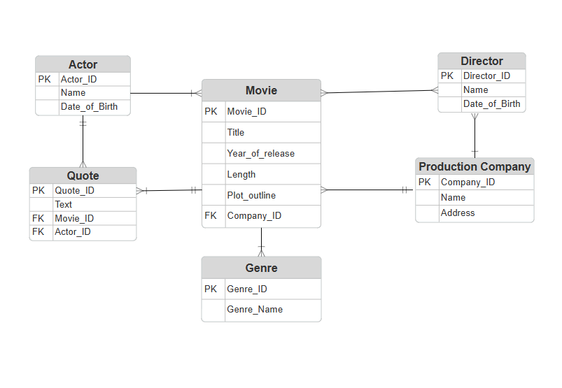
Design a CROWS FOOT entity-relationship diagram for the movie database and enter the design using a data modeling tool such as Erwin or Rational Rose.

3.34
Consider a CONFERENCE_REVIEW database in which researchers submit their research papers for consideration. Reviews by reviewers are recorded for use in the paper selection process. The database system caters primarily to reviewers who record answers to evaluation questions for each paper they review and make recommendations regarding whether to accept or reject the paper. The data requirements are summarized as follows:
- Authors of papers are uniquely identified by e-mail id. First and last names are also recorded.
- Each paper is assigned a unique identifier by the system and is described by a title, abstract, and the name of the electronic file containing the paper.
- A paper may have multiple authors, but one of the authors is designated as the contact author.
- Reviewers of papers are uniquely identified by e-mail address. Each reviewer’s first name, last name, phone number, affiliation, and topics of interest are also recorded.
- Each paper is assigned between two and four reviewers. A reviewer rates each paper assigned to him or her on a scale of 1 to 10 in four categories: technical merit, readability, originality, and relevance to the conference. Finally, each reviewer provides an overall recommendation regarding each paper.
- Each review contains two types of written comments: one to be seen by the review committee only and the other as feedback to the author(s).
Design a CROWS FOOT entity-relationship diagram for the CONFERENCE_REVIEW database and build the design using a data modeling tool such as Erwin or Rational Rose.
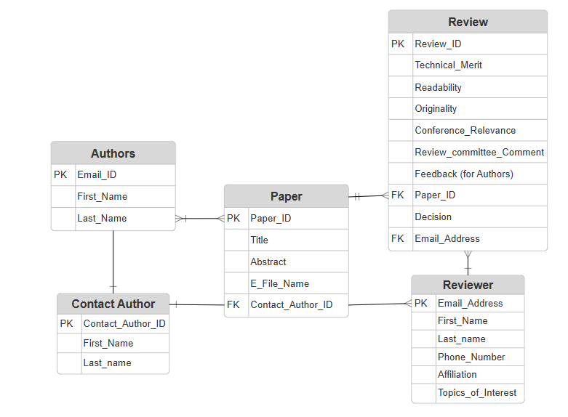

5.17
Consider the following relations for a database that keeps track of booking of apartments by a constructor. (OPTION refers to some specific optional requirements/designs stated by the client to be implemented in the flat):
APARTMENT (Apartment#, Model, Address, Price_perSquareFt)
- Apartment# will be the primary key here but my assumption is that in the option and booking this will be a foreign key relating back to the Apartment.
OPTION(Apartment#, Option_name, Extra_price)
- Option_name will be the primary key here but the apartment# will be the foreign key here referencing back to apartment.
BOOKING(Agent_id, Apartment#, Date, Booking_price)
- Booking ID is my assumption for the primary key here and my assumption here is that Agent_id and Apartment# will be the foreign keys relating back to Agent and Apartment.
AGENT(Agent_id, Name, Phone)
- Agent_ID is the primary key here, this will be a foreign key in the Booking table with no other constraints.
First, specify the foreign keys for this schema, stating any assumptions you make. Next, populate the relations with a few sample tuples, and then give an example of an insertion in the BOOKING and AGENT relations that violates the referential integrity constraints and of another insertion that does not.
Booking:
Agent_ID | Apartment# | Date | Booking_price
7 | 206 | 1/26/2025 | 400
45 | 205 | 1/28/2025 | 50000
67 | 204 | 1/29/2025 | 100000

Agent:
Agent_ID | Name | Phone
7 | Alix Robert | 677-777-1234
45 | Terry Joe | 763-842-2536
67 | Amanda Jane | 754-456-4535

Violation:
- Insert to Booking:
Insert Agent_ID value 12, Apartment# 206, Date 1/23/2025, Booking_price 380000
- This is a violation because we don’t have an agent_ID of 12

Non-Violation:

- Insert to Booking:
Insert Agent_ID value 67, Apartment# 206, Date 1/23/2025, Booking_price 380000
- This is not a violation because the foreign key constraints are respected.

5.19
Consider a STUDENT relation in a UNIVERSITY database with the following attributes (Name, SSN, Local_phone, Address, Cell_phone, Age, Gpa). Note that the cell phone may be from a different city and state (or province) from the local phone. A possible tuple of the relation is shown below:
Name | SSN | LocalPhone | Address | CellPhone | Age | GPA
George Shaw William Edwards | 123-45-6789 | 555-1234 | 123 Main St., Anytown, CA 94539 | 555-4321 | 19 | 3.75

  - Identify the critical missing information from the LocalPhone and CellPhone attributes as shown in the example above. (Hint: How to call someone who lives in a different state or province?)
    - The critical missing info here would be the area code.
b. Would you store this additional information in the LocalPhone and CellPhone attributes or add new attributes to the schema for STUDENT?
- I think storing in the LocalPhone and CellPhone attributes would be the easier option here. It keeps all data related to the phone together rather than a new attribute just for the area code. The only other issue I might see here is if country codes are a necessity as well.
c. Consider the Name attribute. What are the advantages and disadvantages of splitting this field from one attribute into three attributes (first name, middle name, and last name)?
- Advantages: Better data organization and management, allows for a more personalized experience (at work, we like them split so that when we generate letters, we can use informal greetings – that is first name only), better for lookup and filtering (lookup tables, sorting for only a specific first or last name etc.,)
- Disadvantages: Adds complexity to the database, still doesn’t help with cases that have pre-fix or suffix, some people have two last names so this still doesn’t help, ruins data integrity a bit – at my job I see this where there isn’t always a middle name or sometimes a first name isn’t provided to hide donor identities.
d. What general guideline would you recommend for deciding when to store information in a single attribute and when to split the information.
- I say split when you know there will be parts that will be used for different types of reporting – often happens at my job when sorting by names for mailings. Otherwise, if you aren’t doing individual reportings or analysis keep them together.
e. Suppose the student can have between 0 and 5 phones. Suggest two different designs that allow this type of information.
1. At my job we do this by having a main phone, alternate phone, and other phone field under the Contact attribute so something like this would work
2. Another option would be to create an entirely new table for student phone numbers and their types.

Save all documents in the format requested.
Deliverable
Upload your files to Canvas on or before 11:59 pm ET on Sunday.
- Add your file by selecting "Upload" or by dragging and dropping the file.
- Select "Submit Assignment" to turn in your assignment.

